**Experiment No. 01**

**Experiment Name: Implementation of Java Setup in Visual Code**

*Course title: Programming Language II(Java) Lab*

*Course code:*

*Spring 2025*

**Date of Submission**:



**Submitted to-**

###### **Md. Rafsan Jani**

*Assistant Professor*

*Department of Computer Science and Engineering*

|  |  |  |
| --- | --- | --- |
| **Sl** | Class Roll | Name |
| 01 | 2023000010034 | Md Arafat Rahman |

Step-by-Step Java Setup in Visual Studio Code (VS Code)

Step 1: Check Java Installation

* Some PCs might have Java already installed.
* To check if you have Java installed on a Windows PC,
* search in the start bar for Java or type the following in
* Windows +R. Command Prompt (cmd.exe): **java -version**
* If Java is installed, you will see something like this
* (depending on version): 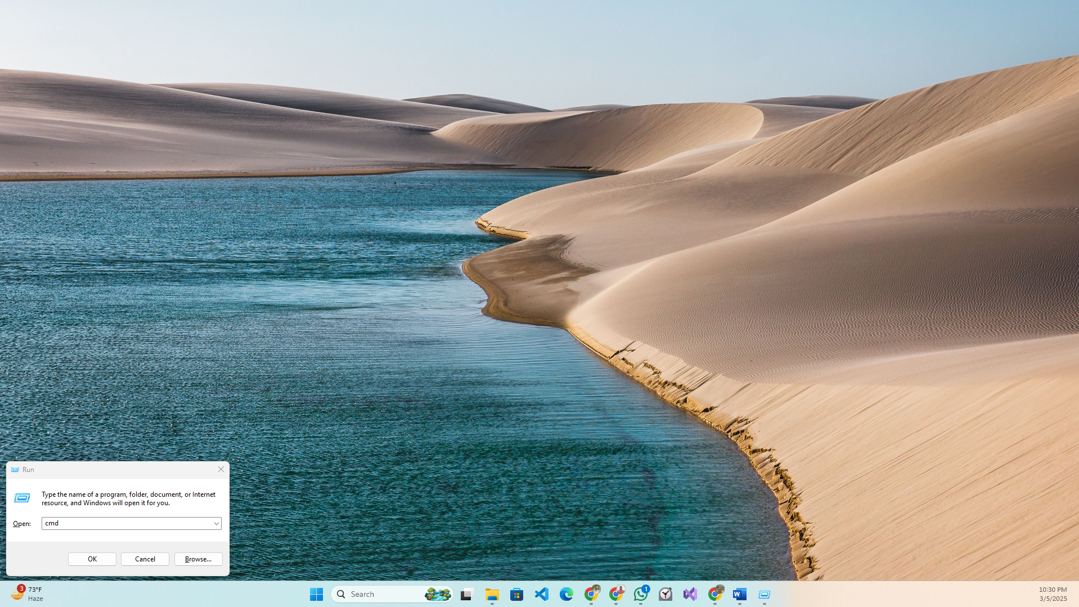

Windows + R

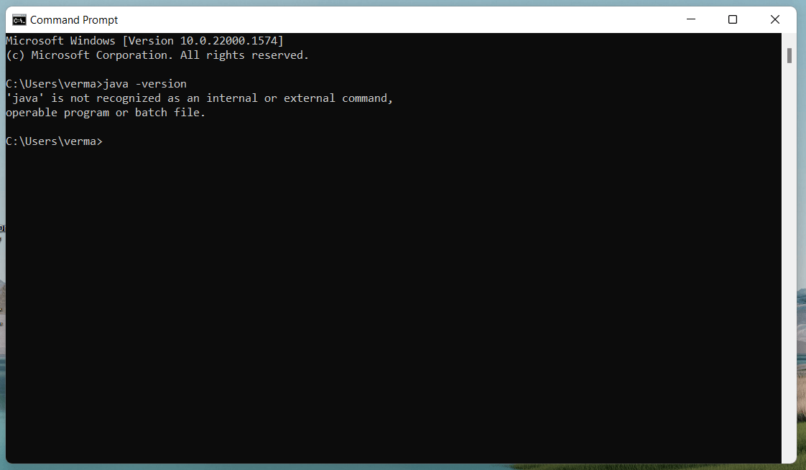

* If you do not have Java installed on your computer, you
* can download it for free from the following link:

<https://www.oracle.com/bd/java/technologies/downloads/#jdk23-windows>

* install This Java JDK
* Go To **This Pc**
* Go to **Local Disk**

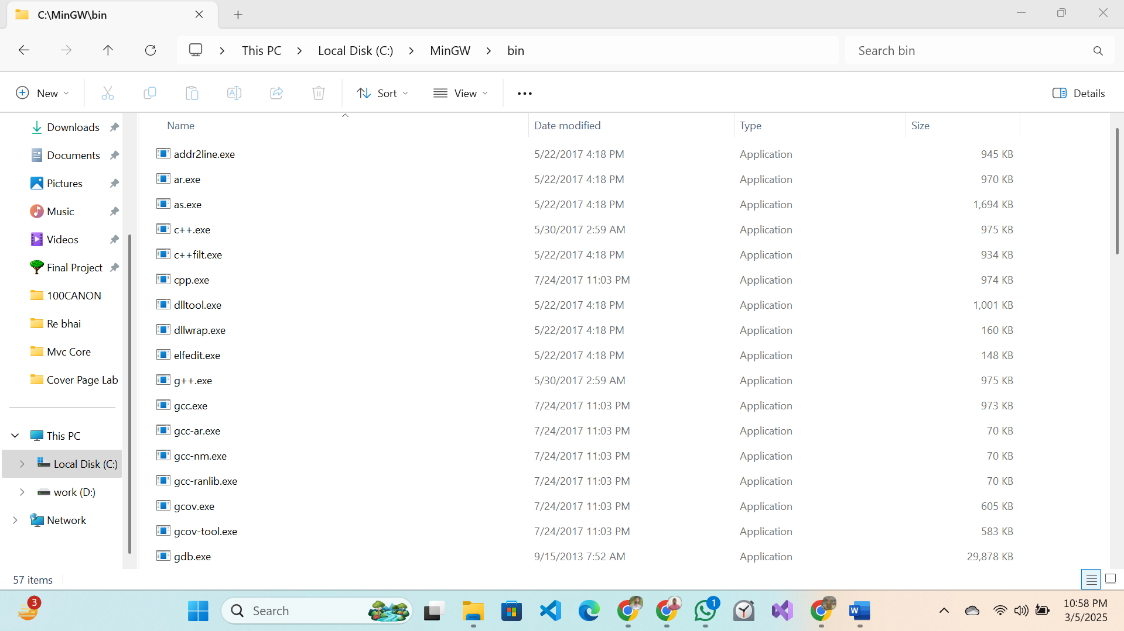

Copy to Path…

1. Go Search Bar….. Environment variables

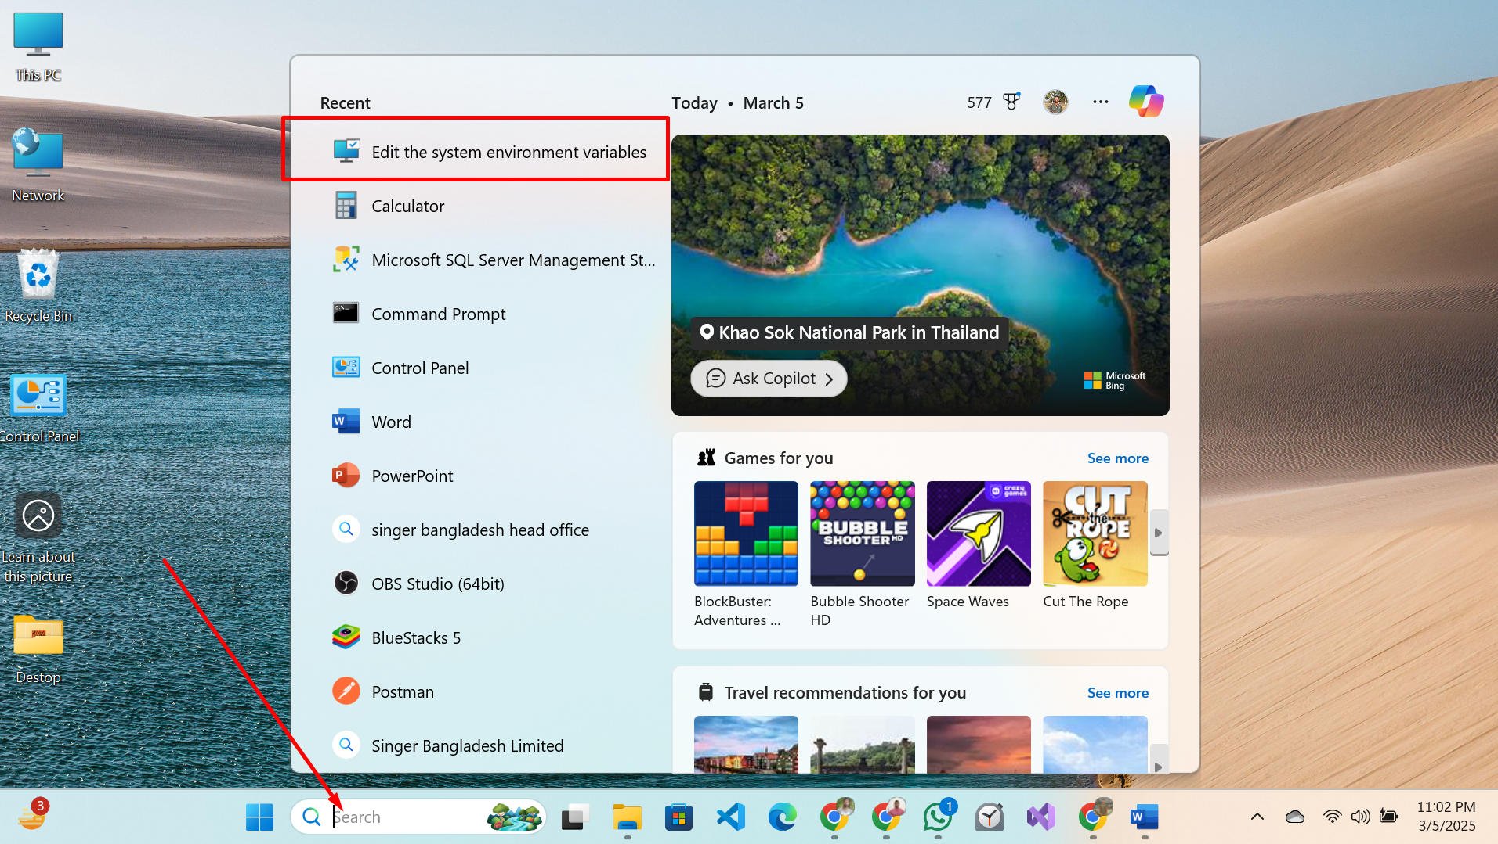

**2**. Click on the "Environment variables" button under the

"Advanced" tab

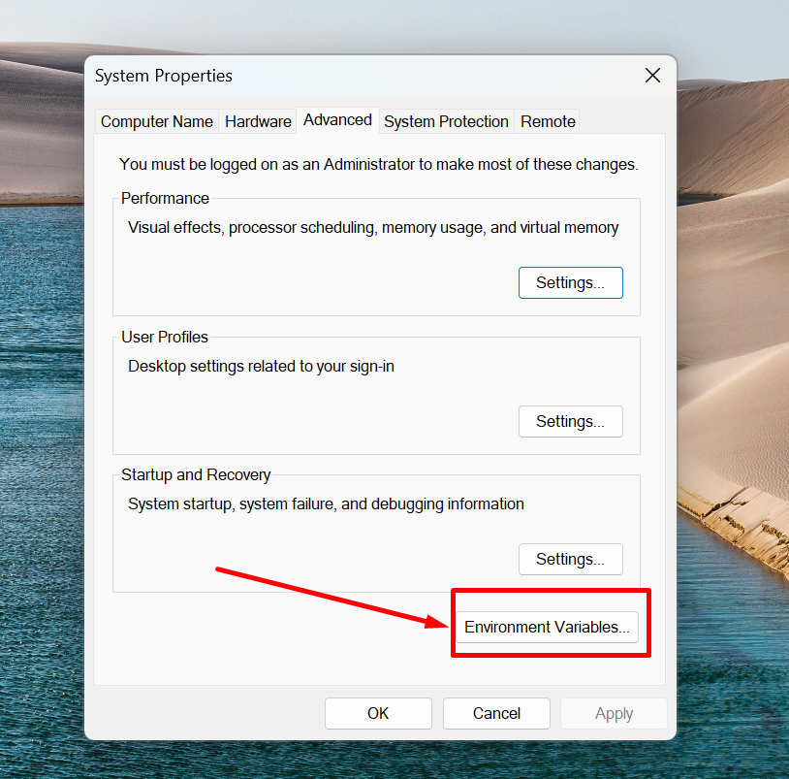

**3.** Then, select the "Path" variable in System variables and

click on the "New" button

Click on the "New" button and a new path with:

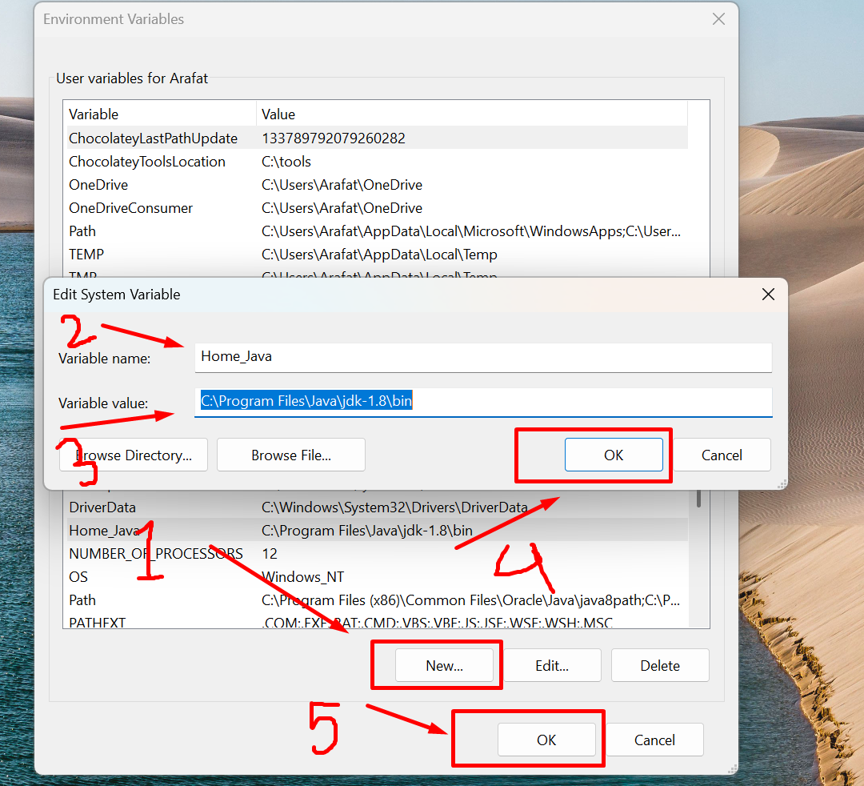

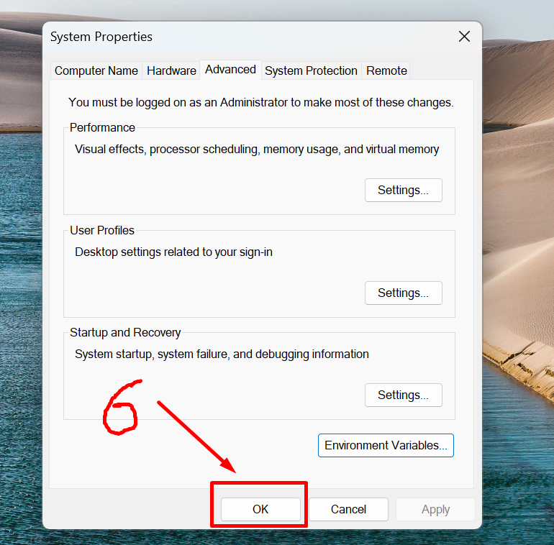

**4**. At last, open Command Prompt (cmd.exe) and type **java -version**

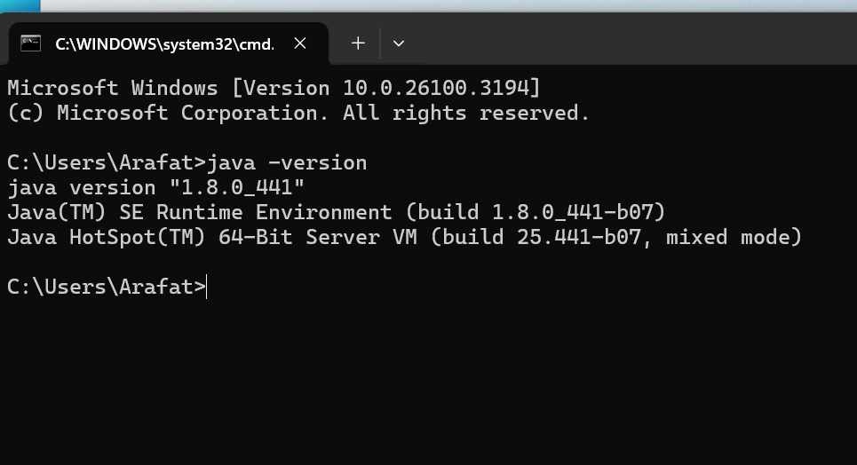

* **VS Code**

Download: <https://code.visualstudio.com/>

**0.Create Java Project Open Vs Code.**

1. Click **File**
2. Click **New File**

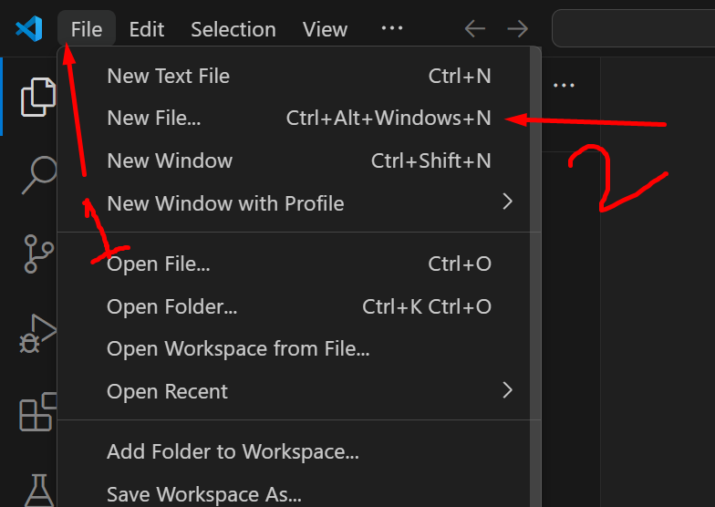

1. Click **New Java Project**

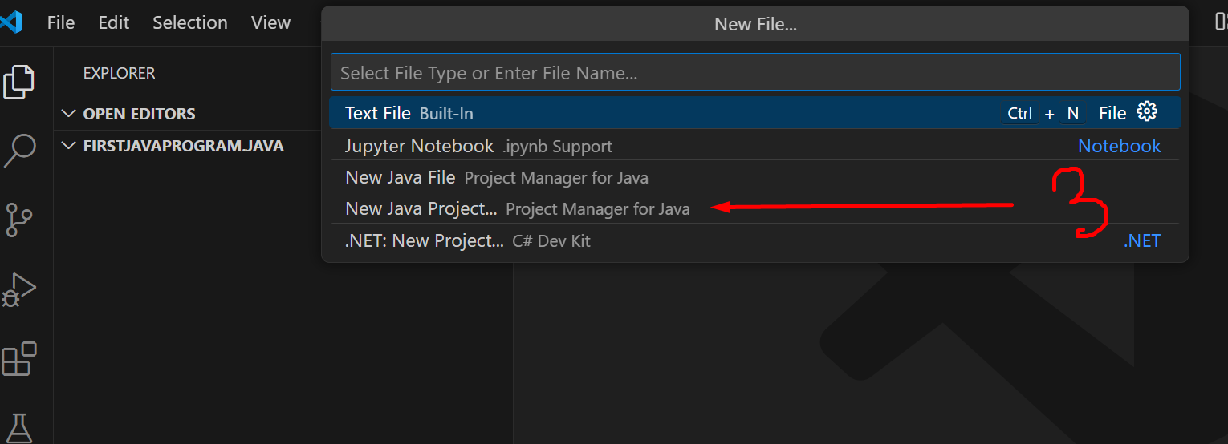

1. Click **No build tools**

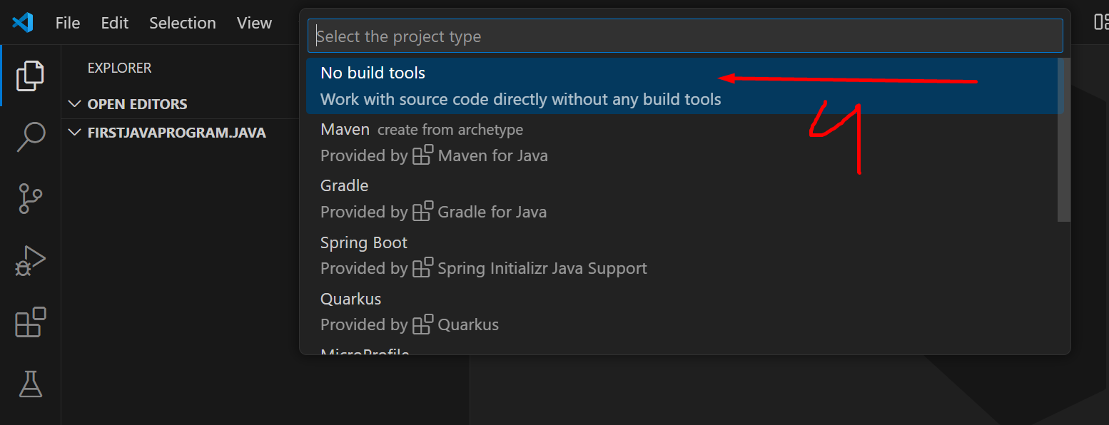

1. Click **Select Folder** Create Java Project

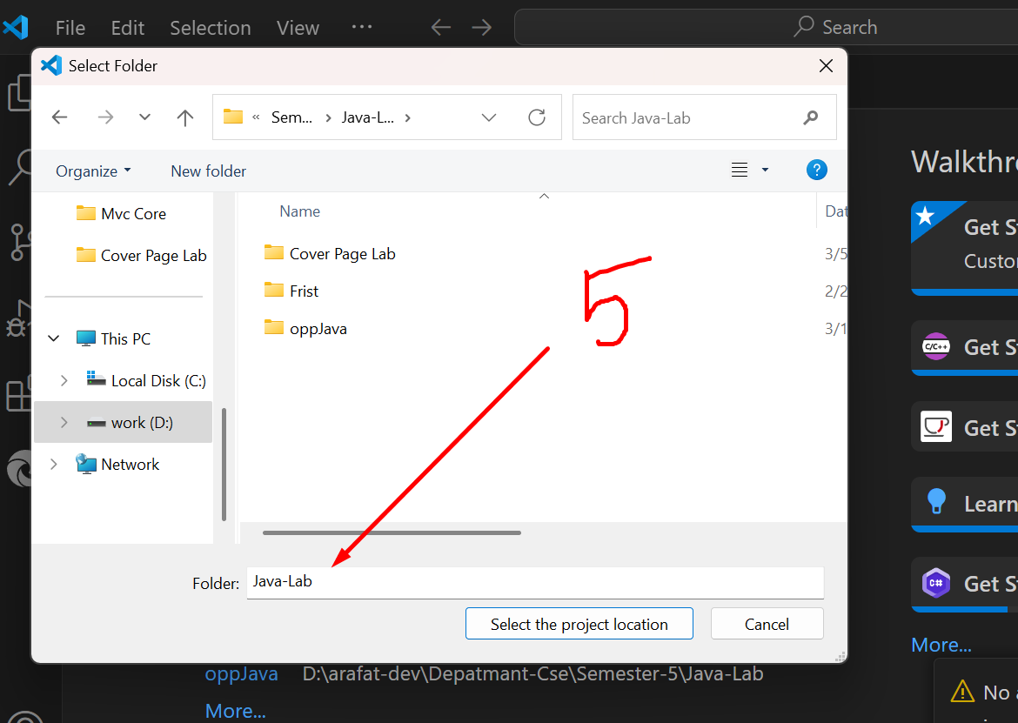

1. **Entry File** **Project Name (Ex:** FirstJavaProgram**)**

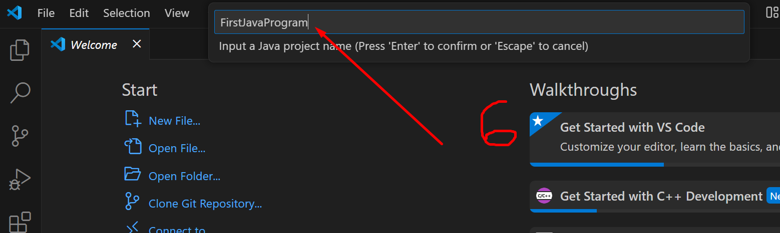

1. Final Create Project Done
2. Live Server
3. Material Icon Theme
4. Peacock

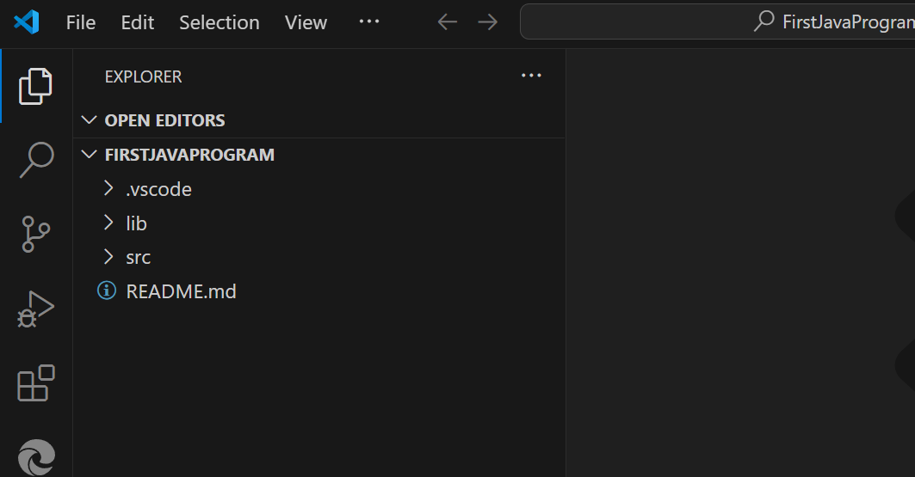

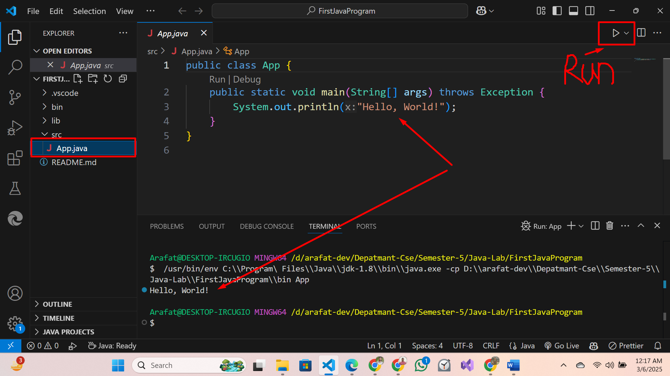

**Run:** Click Run Button ----**Run java**

**Output:** Hello, World

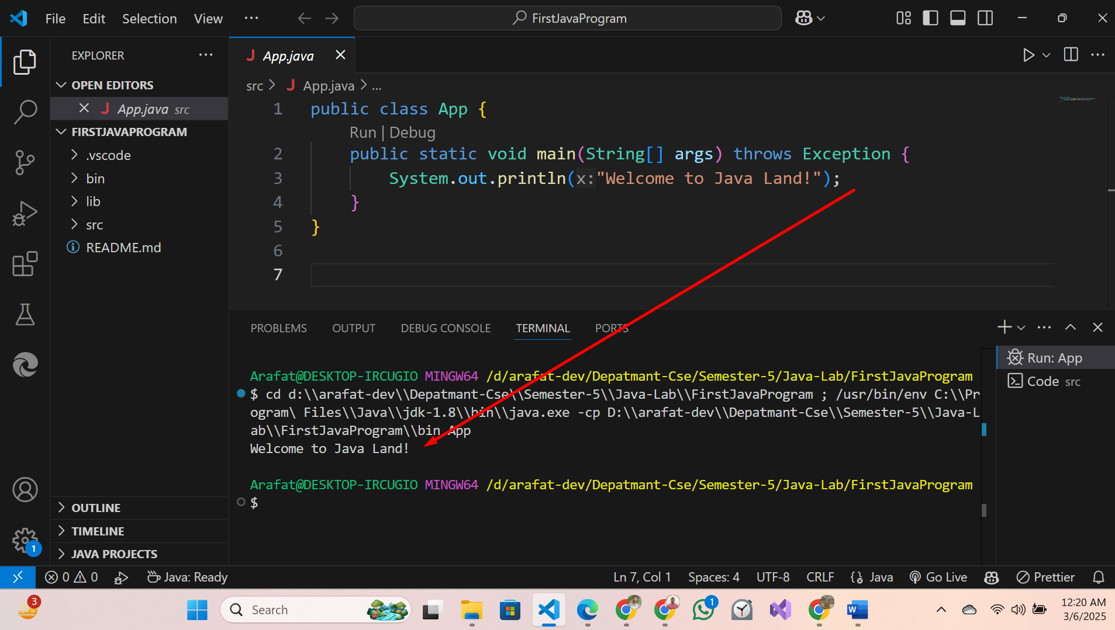

**Output:** Welcome to Java Land!